

Madeleine Johnston

Process Journal

Medical Visualisation

MSc Serious Games and Virtual Reality

Glasgow School of Art

**Overall Goals of Project**

The aim of the project was to create an interactive application with a Medical bases. The team decided to create an inclusive sex education app which would hopefully be further developed into a fully informative application that could be used in schools. This project is currently relative as in recent months, Scotland has become the first country to embed LQBTQI rights and sexual education into the school curriculum. This app aims to be an educational tool that can be used to help teach these new topics to secondary school students.

**How the Project Runs**

The app starts with the main screen that can be accessed at any time during the interactions by pressing the ‘Backspace’ button. This has the different modules that the app can potentially cover. For this project we completed the scenes: About, Genitals and Contraception. The background was chosen as a calming space theme as this subject area can be awkward for some people to discuss therefor having a calming background may help ease some of the user’s anxiety.

**Genitals**

The original body models ended up crashing Unity the scene was loaded or run in game. Eventually the models were changed for lower poly models and the scene ran much smoother. The male and female models rotate and there are two buttons either side on the UI to select if you want to go to the model of the male or female genitals. The code here takes the original colour of the object then changes it to black so the model loads in like a silhouette. The user then needs to select the different parts which triggers the colour to go back to the original colour and displays information about that model part.

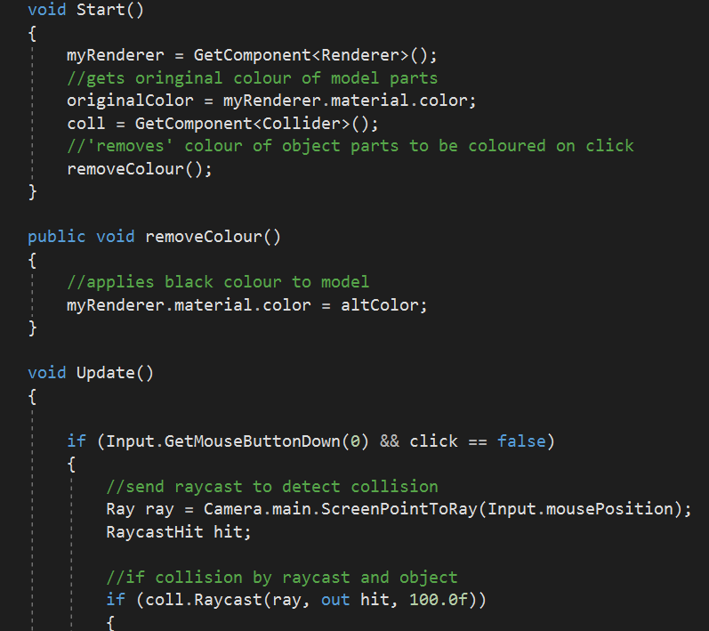

Figure - Highlight script for Genitals

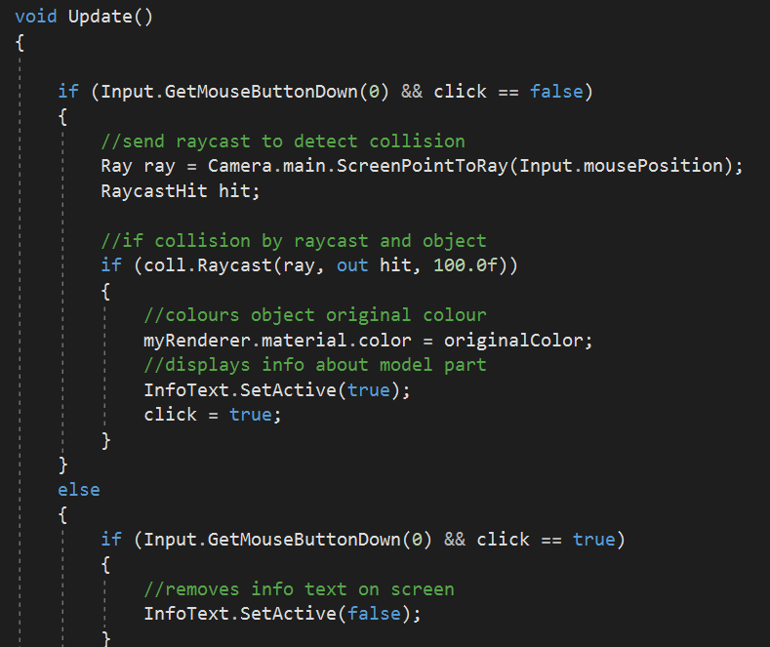

Figure - Highlight script (2)

**Contraception**

This part of the application is more game based. When the scene is selected from the main menu, some information about contraception appears. The camera uses an animation to travel through a model of a blood vessel which then times out using the SceneChange script. This loads the game where the user clicks or ‘zaps’ the diseases in the bloodstream and a counter keeps track of the number they destroy. The user can then return of the main menu using ‘Backspace’. The objects bounce against invisible screen boundaries and if they are hit by the raycast pointer then they destroy and add 1 to the score.

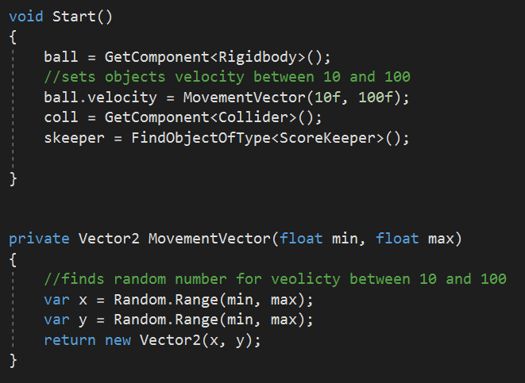

Figure - Bounce script for Contraception scene

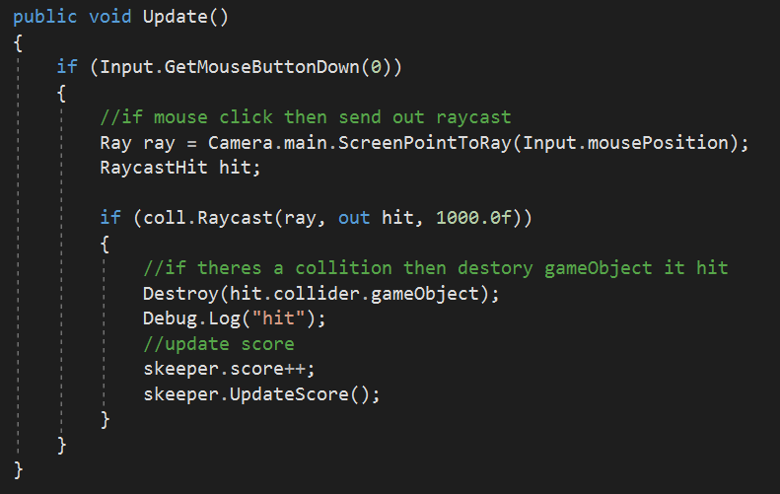

Figure - Bounce script (2)

**Development Process**

The team used Unity collab to share our updates on the project. We met occasionally in person to recap what we had done in the past week. Initially we set up a Pinterest board for ideas and inspirations. We then went with the idea of an inclusive sex education app and divided up the workload. The main menu was designed first then the human models and genital models were added for our first module. Later in development, the contraception module was incorporated as well as the About section.

**Self-critique**

When I was having issues with my models crashing Unity, it took me a while to think about using other models. This has taught me not to get too caught up in my initial ideas it ended up slowing down my development process when I could have quickly and easily changed the models to avoid long loading times. The application also requires more detailed information and facts to provide a solid use for it. The contraception game should also have incorporated a win state once all the disease is cleared from the screen. This would increase enjoyability of the game and hopefully engage the users more in the information being provided alongside.

**Partners Work**

My partner created the ObjectRotate, TextModuleStuff and UIStuff scripts with some minor modifications from myself, for example the loadScene’s. My partner also created the home screen and designed the logo and buttons. They also divided the genital models into individual sections and provided some information about the parts. My partner cleaned up the merging process before hand in.

**Own Work**

I created the ScoreKeeper, SceneChanger(with credit), Bounce and Highlight scripts. I created the Genital scenes and the Contraception scenes including the animation and transitions. I outsourced any models or textures used.

**References**

https://answers.unity.com/questions/710220/guitext-not-updating-score.html

https://answers.unity.com/questions/770855/how-to-destroy-gameobject-when-clicked-on.html

https://answers.unity.com/questions/1446119/moving-a-non-player-object-in-a-random-direction-w.html

https://docs.unity3d.com/ScriptReference/MonoBehaviour.OnCollisionEnter2D.html

https://www.youtube.com/watch?v=iTcj_4WhTpw

https://forum.unity.com/threads/moving-a-game-object-changing-its-direction-on-collision.17137/

https://answers.unity.com/questions/526305/mouse-click-is-detected-twice.html

http://www.bigfatblueberry.com/unity3d-how-to-create-an-easy-ui-popup-window/

https://www.theguardian.com/education/2018/nov/09/scotland-first-country-approve-lgbti-school-lessons